DATE: 15.03.2019
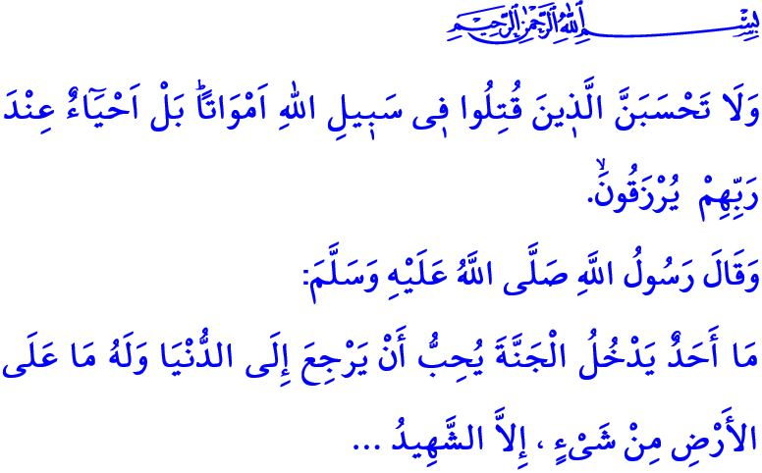
THE TURKISH VICTORY OF THE BATTLE OF GALLIPOLI AND THE ESPRIT DE CORPS
Dear Muslims!
What is called as homeland is the land where people live in peace and security, enjoying the grace of independence and sovereignty. It is the home for those people who sacrifice themselves for the same values and build the future for the same ideals. It is the legacy of people who sacrifice their lives, becoming martyrs, and who give up on their physical integrities, becoming war veterans, to protect their religion, nation, honor, and dignity. As a matter of fact, the return of keeping and defending such a legacy shall be freedom.
Honorable Believers!
The martyrdom, the name for giving souls for the sake of holy values ordered by Allah (s.w.t.) to be protected, is one of the most supreme positions since a martyr takes the risk of abandoning all such beloved ones as his mother, father, wife, and children for the sake of religion, homeland, nation, state, and freedom. In return, the reward of such a unique sacrifice is to be honored by endless kind treatments and honoring of the Almighty Allah (s.w.t.). In this respect, He refers to such a supreme position to be reached by martyrs as follows: “And never think of those who have been killed in the cause of Allah as dead. Rather, they are alive with their Lord, receiving provision, Rejoicing in what Allah has bestowed upon them of His bounty, and they receive good tidings about those [to be martyred] after them who have not yet joined them - that there will be no fear concerning them, nor will they grieve.” Moreover, the Prophet Muhammad (saw) described the rank position of martyrs in the Hereafter as follows: “No one accepted to the Heaven shall desire turning back to earth even if everything on earth belongs to them. Only a martyr shall desire turning back to earth and being a martyr again and again thanks to the kind treatments and honoring he experienced.”
Honorable Muslims!
For centuries, our ancestors have protected the lands we live on through their faith in Allah (s.w.t.), their love for homeland, their courage, and sacrifice. In no period of the history have they capitulated their faith and freedom, nor have they ever surrendered to any tyranny. They have battled for every corner of the homeland with the understanding “I shall be a martyr if I die and a veteran if I survive,” and under no circumstances have they let the enemies in our homeland that they took as more precious than their lives. The history is full of heroic sagas of our glorious ancestors tackling with any challenges for the sake of their homeland and sanctity. Çanakkale Victory was precisely one of such sagas in which faithful chests reared with the love for Allah (s.w.t.).
Dear Believers!
Çanakkale Victory is the name of the great battle undertaken by a whole nation including women, men, the young, and the old, standing shoulder to shoulder. Çanakkale is where the gallant Mehmetçik, the namesake of whom is the Prophet Muhammad (saw), shouted out “Çanakkale is Impassable” to the world, and where they fell on the ground upon being shot on their immaculate foreheads. Çanakkale Victory is one that was won by those with hearts full of unshakeable faith, those with hearts beating with love for homeland, against the great powers despite all poverty and unfortunateness.
Honorable Muslims!
The Battle of Çanakkale showed us that under no circumstances, those hearts beating for the purposes of getting the approval of Allah (s.w.t.) and making i’la kalimatillah (glorifying and disseminating the words of Allah (s.w.t.)) dominant in the world, could be enslaved. Our flag bearing the color of our martyrs’ blood will never stop waving high in the sky until as long as only one soul is left on these lands. The adhans, the shahadah of which is the base of the religion, shall always sound loud. In case of a necessity, many souls shall pass away for such sake; however, no disallowed hand shall be able to touch upon what is sacred for us. Those who have designs against damaging the unity and solidarity of our nation, in servitude to Allah (s.w.t.) only, shall never be able to succeed.
Dear Believers!
Today, what falls upon us is to comprehend the magnificent spirit having reared in Çanakkale, to gather around our values that make us ‘us’, and the nation that we are, and to transfer them to our next generations. It is our responsibility to bring the sanctity bestowed on us by our martyrs and veterans under the same awareness and ideals.
We should always remember that as long as we keep the awareness of unity, solidarity, brotherhood and sisterhood alive and preserve our values, there can be no malicious attack we cannot resist, no fight we cannot come out as victorious, and no victory we cannot gain.
Honorable Believers!
The hateful attack at our Muslim brothers during their worship in New Zealand today—Friday as the feast for Muslims—has deeply hurt our hearts. This should be clearly noted that no attack at worship places and Muslims can be acceptable, regardless of where it takes places in the world, who does it, and why it is done.
In the face of such provocative incidents, we as Muslims should act with common sense. We wish Allah’s mercy upon our martyred brothers, and quick recovery for our injured brothers. May Allah protect the Muslim Ummah from any kind of troubles.

Ali İmran, 3/169-170.
Bukhari, Jihad, 21. General Directorate of Religious Services

